Emmaus Lutheran School

Fine Arts Curriculum

Rationale based on Scripture
God is the Creator of all things, including fine arts. Our school is committed to providing students with a quality education in fine arts so they can function effectively as Christians in their church, community, and country. A quality education in fine arts will help students succeed in high school, in the work place, and help them witness to friends, neighbors, and co-workers about our Savior.

Exit goals for graduation
Students will demonstrate proficiency, understanding, and/or commitment to the following set of exit goals upon graduation. The level of proficiency of these exit goals will be dependent upon the individual gifts and effort of the student and at what grade the student started attending Emmaus.
- Demonstrate a positive attitude toward fine arts
- Express joy in singing in worship service
- Understand basic music theory
- Ability to follow written music
- Exposure to Lutheran hymns and their history
- Exposure to historical composers
- Exposure to the different elements of art
- Understanding of the time, patience, and skill needed to complete art assignments well.
- Exposure to historical artists

Grade specific measureable objectives and evidence of continuity from grade to grade
At the end of each school year, students will demonstrate proficiency, understanding, and/or commitment to the following set of grade specific measureable objectives in these classifications: knowledge, skills, and attitudes.
The level of proficiency of these measureable objectives will be dependent upon the individual gifts and effort of the student and at what time of year the student started attending Emmaus.

Music
Our music teacher uses Sing and Make Music and a variety of educational resources from Teachers Pay Teachers to teach our students the basics of music theory, history of classic music composers, and the history of Lutheran hymnody. Each classroom has music class and hymnology class one day of the week. Students in grades 3-8 also participate in Hand Chimes one day per week.
Our students sing in church several times in church services throughout the year as a class, a group of classes, or as a whole school. In addition, the students play hand chimes for worship services several times a year. These opportunities demonstrate to our students the joy of sharing the gospel message through song and encourage faithful church attendance.
In addition, the students prepare for musical performances for our Veterans Day celebration and our end-of-year Family Entertainment Night. Those with additional gifts (vocal, instrumental, acting, etc.) are often asked to use their gifts for these activities.
Following is the Scope and Sequence Chart of Sing and Make Music. This chart indicates the objectives taught at each specific grade level.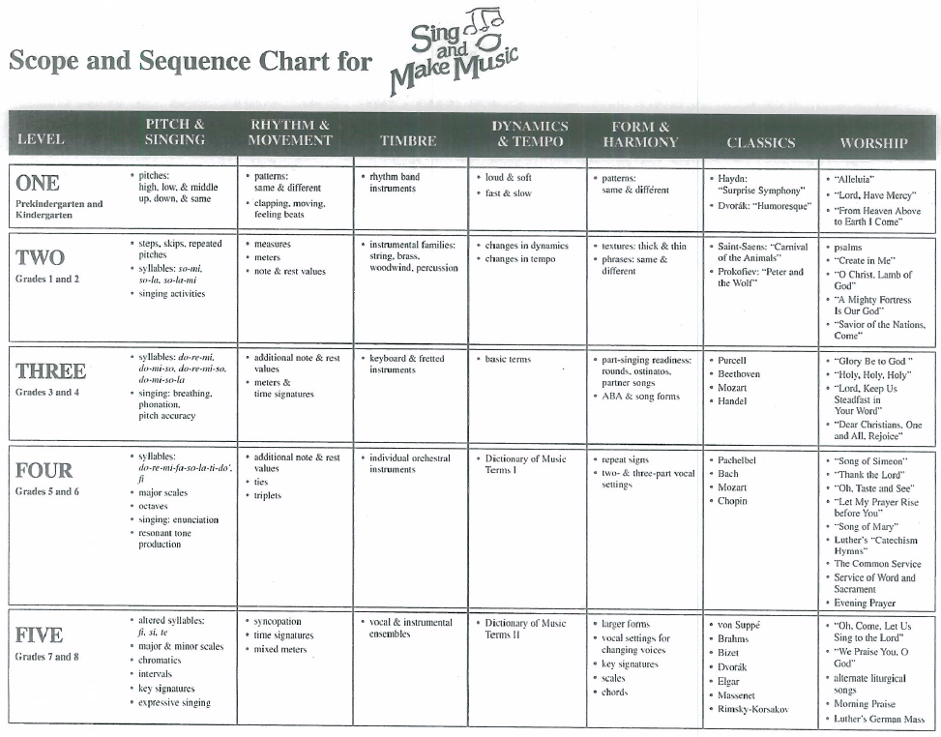

Art
Art class is taught in our classrooms on Fridays. The younger grades do art projects that teach artistic skills, but the projects don’t always follow the elements of art. The projects often pertain to the curriculum, the season of the year, or an event at school. Art class in the upper grades (specifically 7th-8th) focus more on the elements of art (i.e., line, shape, form, color, value, texture, space, and perspective). Projects for several weeks in a row are specific to a theme, so students learn the knowledge and skills necessary to complete works of art in that element of art.
During the school year, students’ art projects are posted in the fellowship hall for school families and congregation members to see. This is an opportunity they have to share their God-given abilities with family, friends, and congregation members.

Assessment of the academic growth and achievement of each student
Each individual teacher will assess the academic growth of their students on a regular basis through class questioning, worksheets, and projects.

